Solutions To Hands-On Exercises - Java Inheritance

**Setup Instructions:**

1. Create a new Word document- “AssignmentsDay4.docx” .
2. Answer Assignment 01.
3. Create a new Java Project called “FullStackDay4”.
4. Create your classes in the specified package.
5. Define your classes and interfaces as given below for each assignment.

Assignment 01

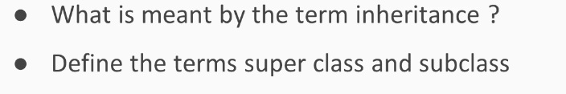

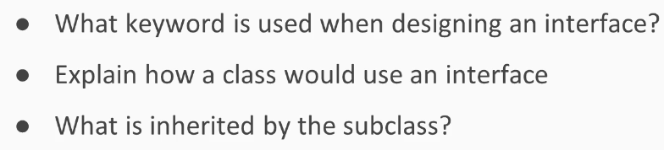

Assignment 02

Create classes and an interface as below:

TwoDShape

1. Create a public abstract class TwoDShape in a package “shape”.
2. Create 2 private instance variables of type int - xPos and yPos.
3. Create one parametrized constuctor to set the values of the above variables.
4. Implement getters and setters.
5. Create a public abstract method calculateArea( ) with a return type of double. The method body should be empty.
6. Create a public abstract method calculatePerimeter( ) with a return type of double. The method body should be empty.
7. Implement a toString() method for the class.

Solution:

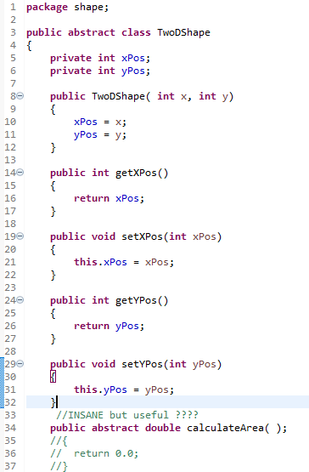

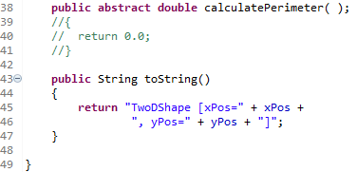

DrawShape

1. Create a public interface DrawShape in package “shape”.
2. Create 2 public static final variables of type int - ZOOM_PLUS and ZOOM_MINUS.
3. Set ZOOM_PLUS = 1 and ZOOM_MINUS= -1.
4. Create a public abstract method draw( ) with a return type of void.

Solution:

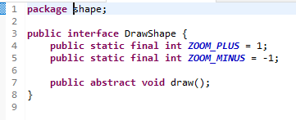

Circle

1. Create a public class Circle in package “shape”.
2. Circle extends TwoDShape and implements DrawShape.
3. Create 1 private instance variables of type double called radius.
4. Create one parametrized constuctor passing in 2 ints - x and y.
5. Set the radius equal to 1.0 in the above constructor.
6. Compilation will fail as the code is written now.

*What do you need to do to get the code to compile?*

*Hint: Call the superclass constructor with the appropriate arguments.*

1. Create a parametrized constuctor passing in a double and 2 ints -

- double newValue

- int x

- int y

1. Set the instance variable radius equal to newValue in the above constructor.
2. Compilation will fail as the code is written now.

*What do you need to do to get the code to compile?*

*Hint: Call the superclass constructor with the appropriate arguments as in Step 6.*

1. Implement a getter and setter for the variable “radius”
2. In the setter, name the parameter as “newRadiusValue” .
3. If newRadiusValue is negative, set radius equal to 1.
4. Else set radius equal to “newRadiusValue” .
5. Implement the following 2 methods:

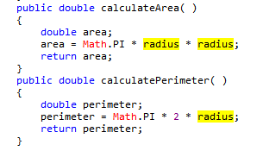

1. Implement a toString() method for the class.
2. Implement the draw() method as below:

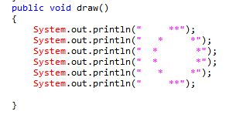

Solution:

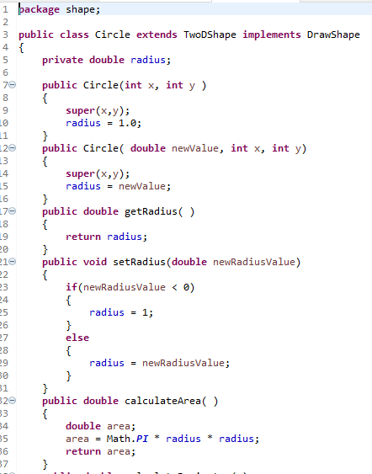

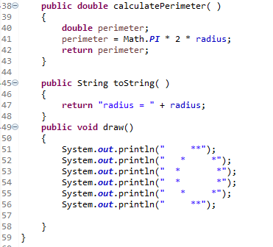

1. Lets’s create a classe “TestCircle” in the same package to test the above:

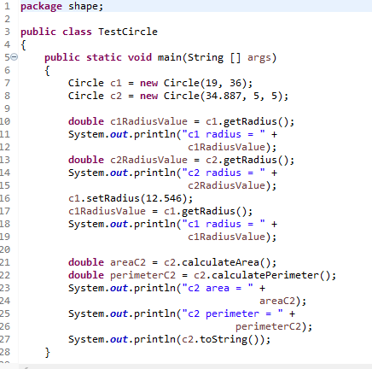

Output:

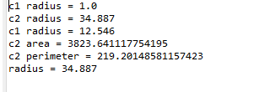

Assignment 03

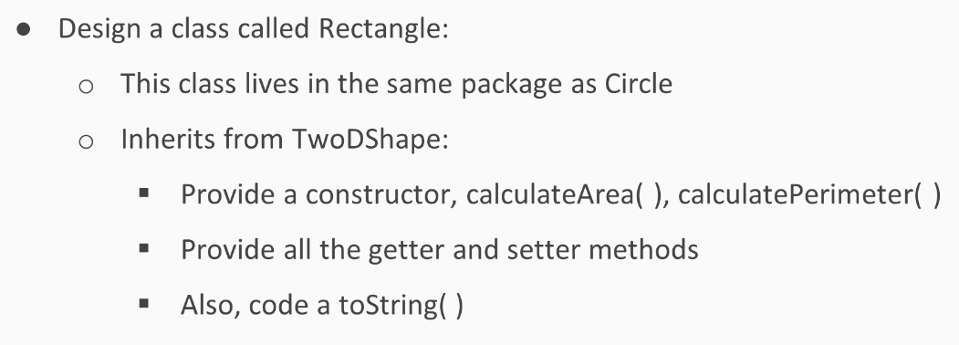

1. Create a public class Rectangle in package “shape”.
2. Rectangle extends TwoDShape and implements DrawShape.
3. Create 2 private instance variables of type double called length and width respectively.
4. Create a no-args constructor.
5. Call the superclass constructor with the values (0,0).
6. In the no-args constructor, set length as well as width equal to 1.0.
7. Create a parametrized constuctor passing in 2 doubles and 2 ints :-

- double length

- double width

- int x

- int y

1. Call the superclass constructor with the appropriate arguments.
2. If the passed in values of either length or width is negative,*(use conditional OR)*

set the corresponding instance variables (length and width) equal to 1.0.

else

set the corresponding instance variables (length and width) equal to the values passed in.

1. Implement the following methods in Rectangle class.

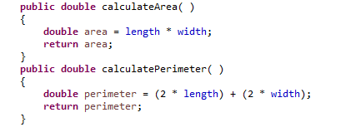

1. Implement getters and setters.
2. In the setWidth() method,

if the width passed in is -ve, then set width equal to 1.0.

else

set width equal to whatever value is passed in.

1. In the setLength() method,

if the length passed in is -ve, then set length equal to 1.0.

else

set length equal to whatever value is passed in.

1. Create a method isSquare() with a return type of boolean.

Implement the logic to return true if length is equal to width else return false.

1. Create a toString() method.
2. Implement the following draw() method.

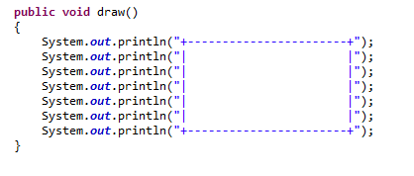

Solution:

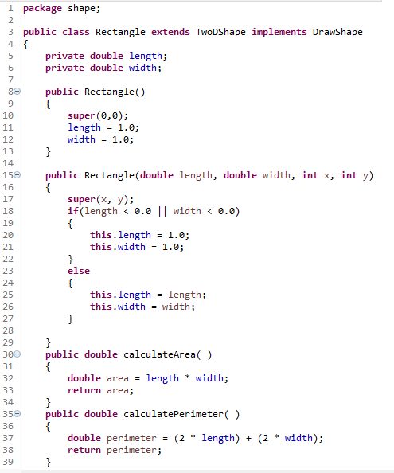

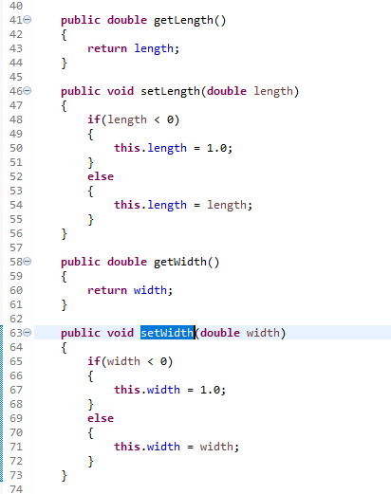

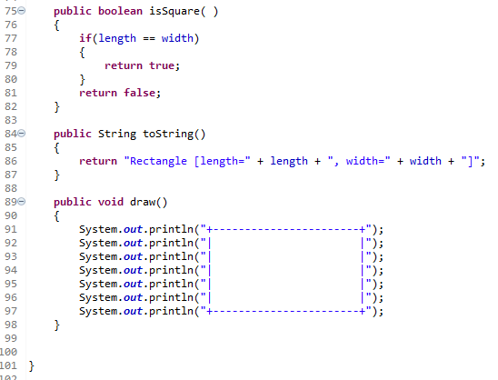

1. Lets’s create a class “TestingRectangle” in the same package to test the above:

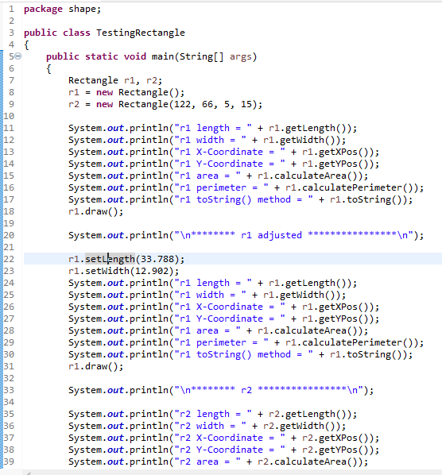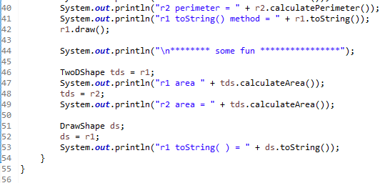

Output:

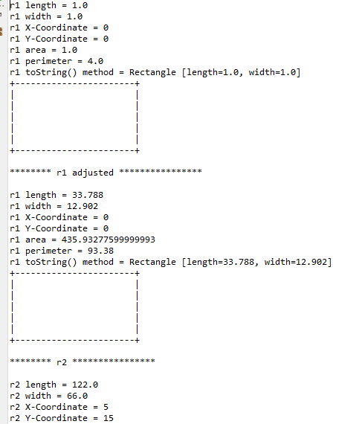

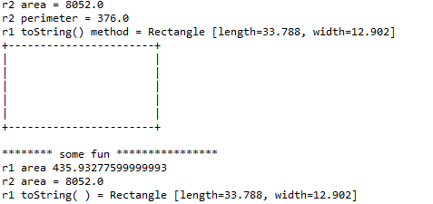

In Day 4, you created a class to test Static Polymorphism (method overloading).

Now let’s create a class to test Dynamic Polymorphism(method overriding).

1. Create the following test class:

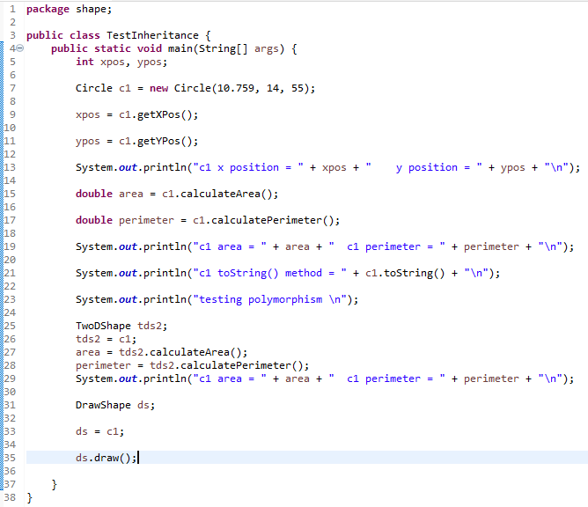

Output:

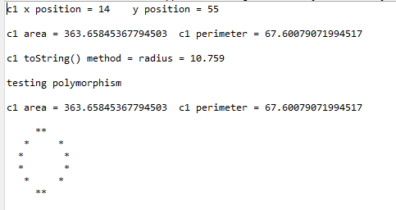

Assignment 04

*** This is a doSelect Test Problem.

Create the following classes in a package “doselect.practice1”.

Sid recently started working for an online bookstore and has been given the task of creating a status maintenance system for all the books. Deadline is knocking at the door, and he is yet to finish his task. Can you help Sid develop the system?

He has created the base class Book as described below:

class Book:

data fields:

title : String variable which stores the title of the

book

author : String variable which stores the name of the author

(comma separated names if there are more than one author)

pages : Integer variable which stores the number of pages of the book

methods:

Book(String title, String author, int pages) :

Constructor to initialise the primary details

(title, author, pages) of the book

getDetails() :

Returns the title and author's name as a single

string separated by '-'

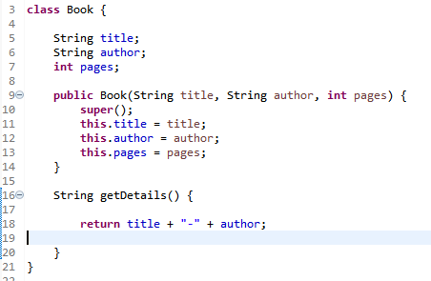

Now, your task is to define the following classes which are subclasses of Book class. Consider default visibility of classes, data fields and methods unless mentioned otherwise.

class Ebook:

data fields:

appxSize: int variable denoting the approximate size of the book in kilo-bytes(KB)

format: String variable denoting the format of the e-book (mobi, pdf or epub)

methods:

Ebook(String title, String author, int pages, String format):

Constructor to initialise the details of the book and calculate appxSize by calling setAppxSize()

setAppxSize():

Sets the approximate size of the Ebook calculated as:

15 times the number of pages for mobi format

10 times the number of pages for pdf format

5 times the number of pages for epub format

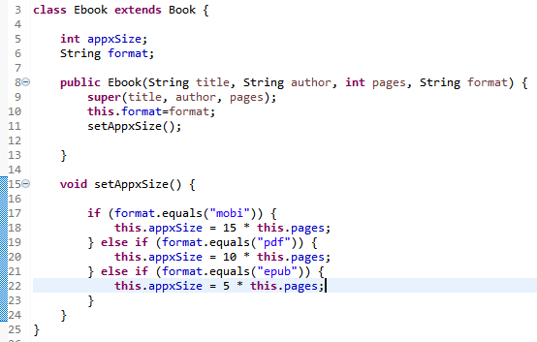

class PrintedBook:

data fields:

available: integer variable denoting the number of available copies of the book // max value = 1000

basePrice: double variable denoting the base price of the book

sellingPrice : double variable denoting the final selling price of the book

methods:

PrintedBook(String title, String author, int pages, int available, double basePrice):

Constructor to initialise the details of the book

and calculate sellingPrice by calling setSellingPrice()

setSellingPrice():

Sets the selling price of the book calculated as:

add 5% tax and 2% of the quantity (1000-available)

to the base price to get the selling price

buy():

Decrease availability by 1 if it is greater than zero.

Update the selling price.You don't need to write the main function.

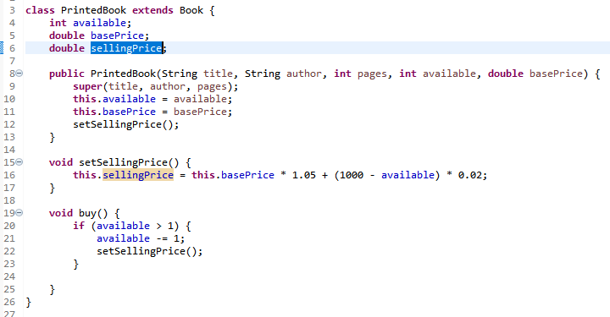

Write the following class to test the above:

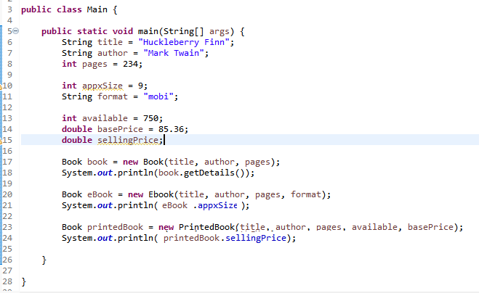

The class will not compile as written. Compilation will fail on lines 21 and 24.

Make the appropriate changes to the code on on lines 21 and 24 to get the class to compile.

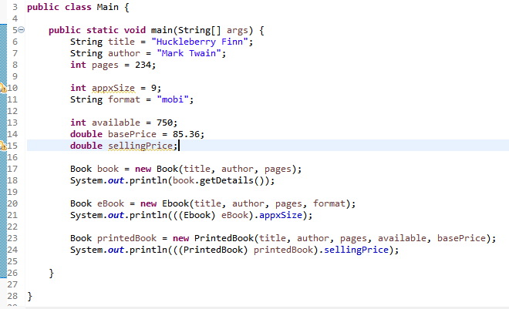

Output:



Assignment 05

*** This is a doSelect Test Problem.

Create the following classes in a package “doselect.practice2”.

Jake's school teacher gave him an assignment to write a Java program which calculates the area of a convex quadrilateral. The quadrilateral is described by the co-ordinates of four 2-dimensional points: (x1, y1), (x2, y2), (x3, y3) and (x4, y4). Jake is busy doing his Maths assignment. So, he asks for your help to complete the Java assignment for him, since you are good at it. He remembers that he has already done a similar assignment for triangle. So, he suggests you to take help of it.

The classes he had created already are described below. Consider default visibility of classes, data fields and methods unless mentioned otherwise.

class Point:

data fields:

x: integer variable denoting the x co-ordinate of the point

y: integer variable denoting the y co-ordinate of the point

methods:

Point:

Constructor to initialise the point

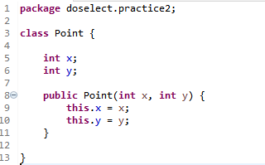

class Triangle:

data fields:

p1, p2, p3: Three Point objects denoting the

points that describes the triangle.

methods:

Triangle:

Constructor to initialise the triangle

getArea:

Returns a double variable denoting the area

of the triangle.

Use the following to calculate the area of a triangle.

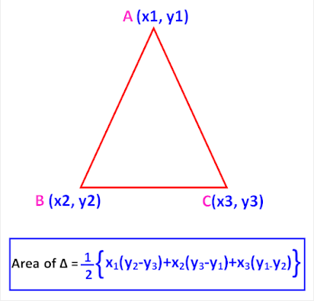

Given:

Point p1, p2, p3;

We may calculate area as follows:



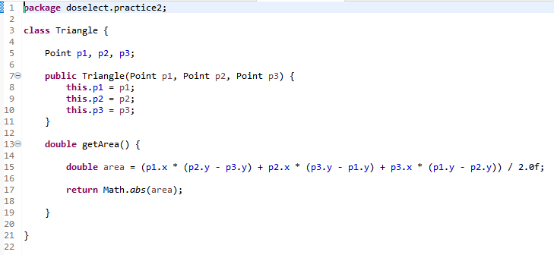

Your task is to create a class named Quadrilateral which should be a subclass of Triangle. The description is given below:

class Quadrilateral extending the class Triangle:

data fields:

p4: The fourth point of the quadrilateral

methods:

Quadrilateral:

Constructor to initialize the quadrilateral

getArea: //overridden method

Returns a double variable denoting the area of

the quadrilateral, use the getArea method of

Triangle class to calculate it

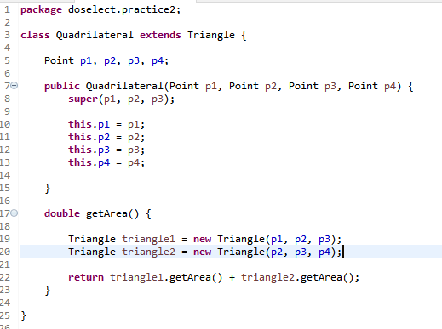

Constraints

All the co-ordinates lie between -100 and 100.The points are given in either clockwise or anti-clockwise order.

Input

An object of Triangle class or Quadrilateral class.

Output

A double variable denoting the area of the Triangle or

the Quadrilateral.

Write the following class to test the above:

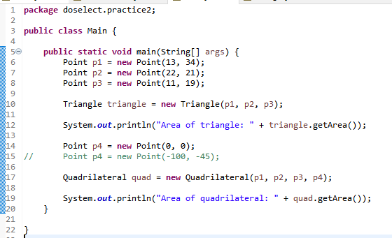

Output:

